**REPORT**

**Day 4 Of Hackathon**

**Dynamic Frontend Components**

**NIKE**

**FUNCTIONAL DELIVERABLES:**

**1.FRONTEND :**

The homepage or website landing page,

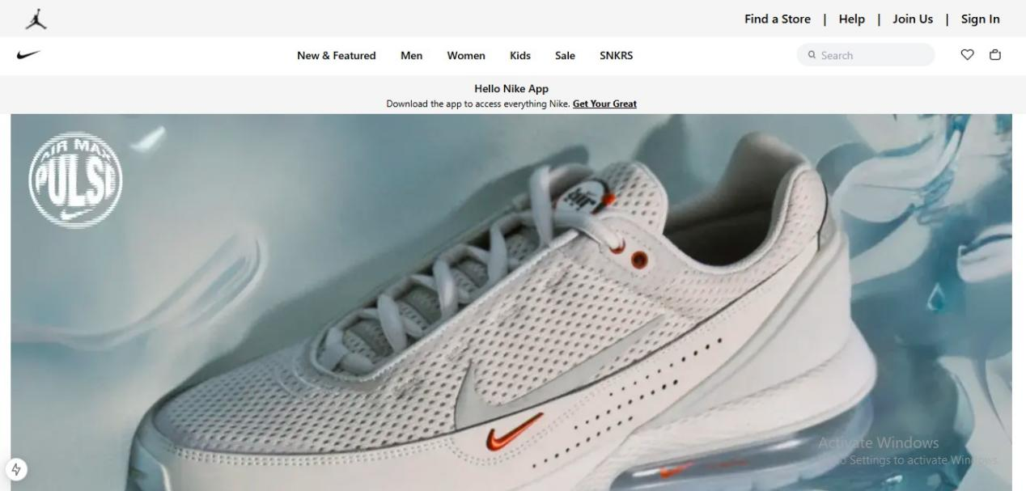

**2.PRODUCT LISTING PAGE COMPONENTS:**

The product listing page displays a collection of products fetched dynamically from an API.The list of products is updated as per the latest data from the back-end, ensuring a real-time experience for users.It includes dynamic rendering of product names, images, prices, and descriptions based on the data provided.

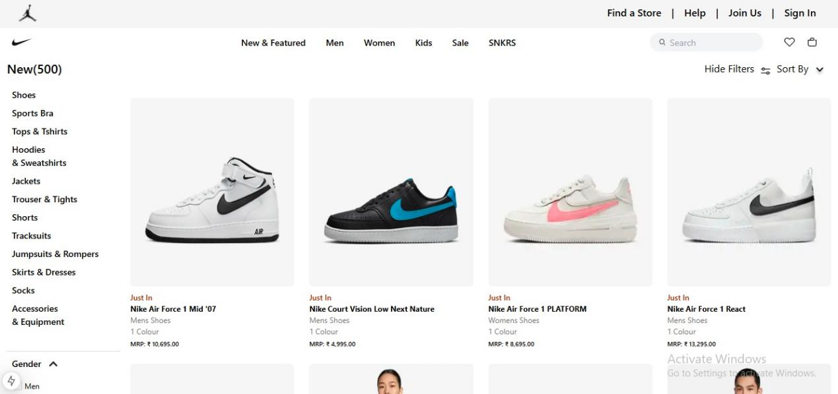

**3.Individual Product Detail Pages:**

Each product in the listing page links to its individual product detail page. This page includes all the relevant details for a specific product, such as the product name, description, price, images, and availability.

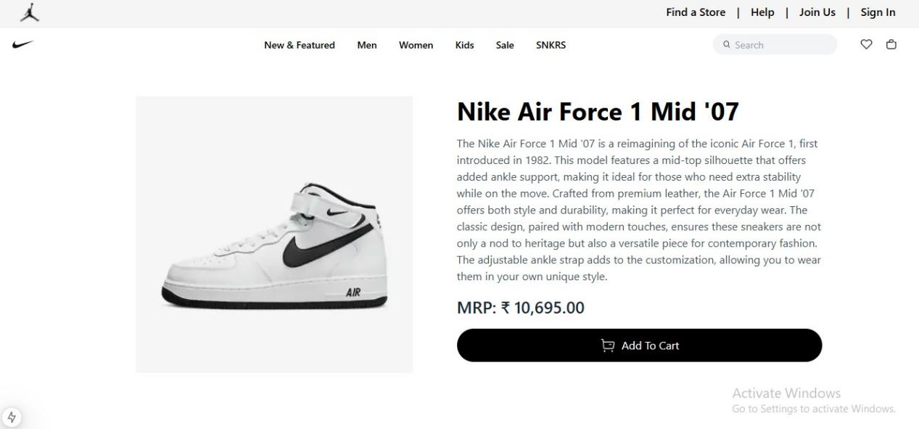

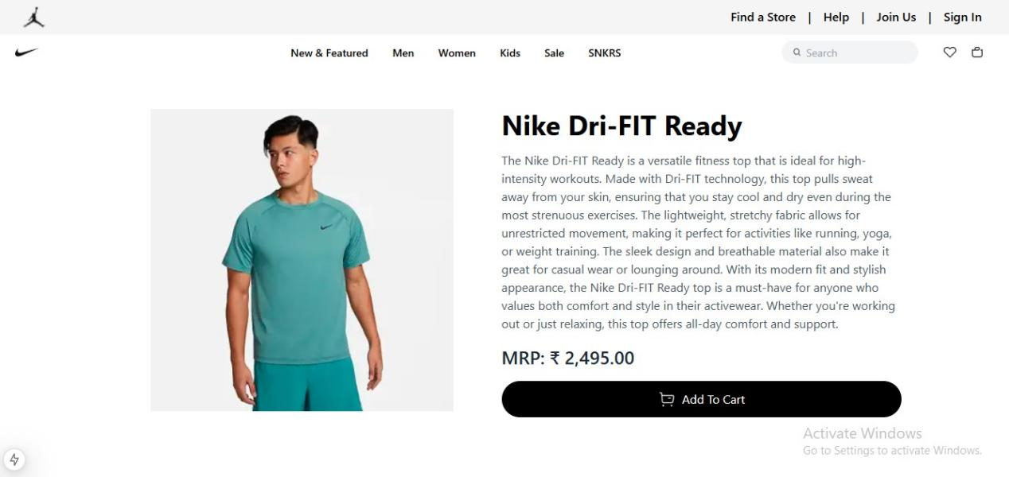

**4.CART COMPONENT:**

User can add products manually through ‘Add to Cart’ button.Which will be redirect to cart page.Make cart page functionality.Cart page shows products which are added in cart,total amount and a checkout button to place order.

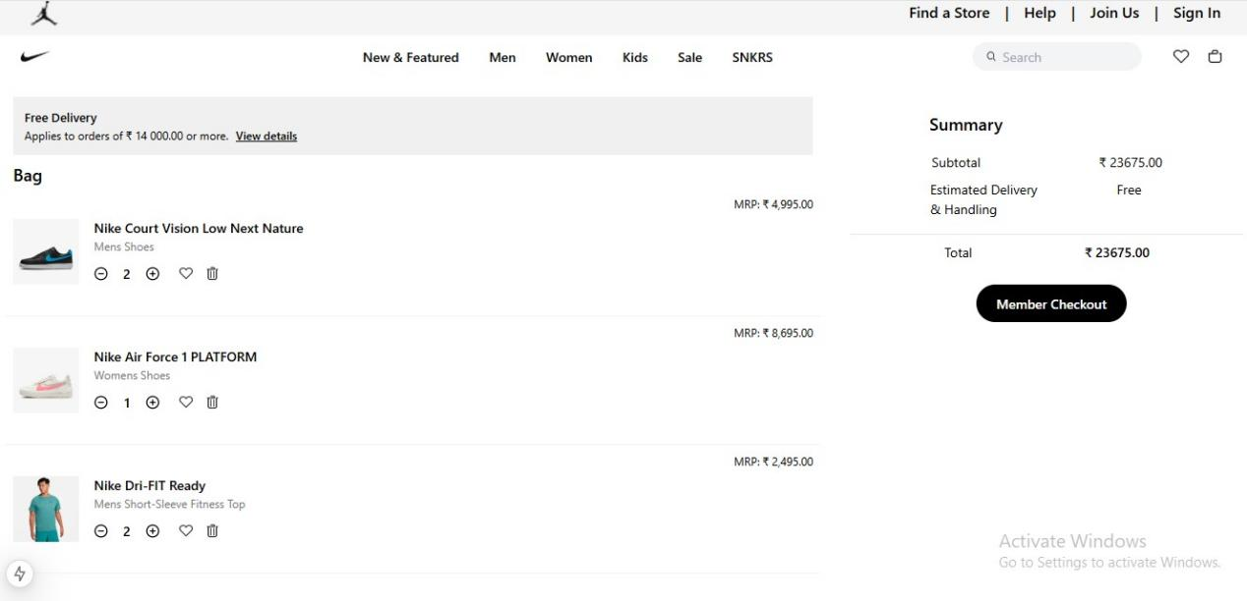

**5.CHECKOUT FUNTIONALITY COMPONENT:**

Before place order user required to add informations like name,address,contact no, and postal code to place and order.

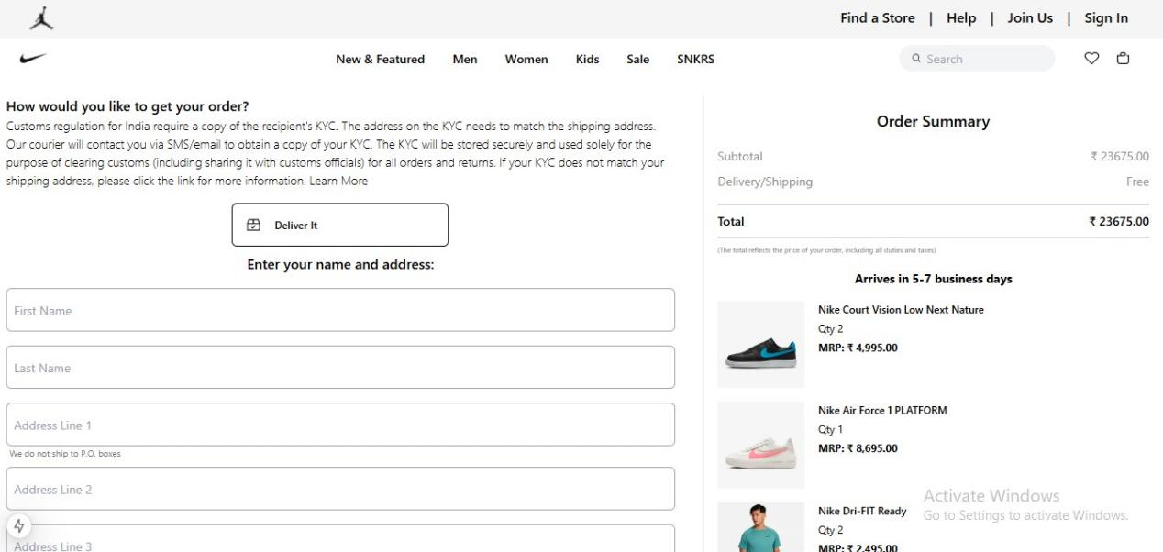

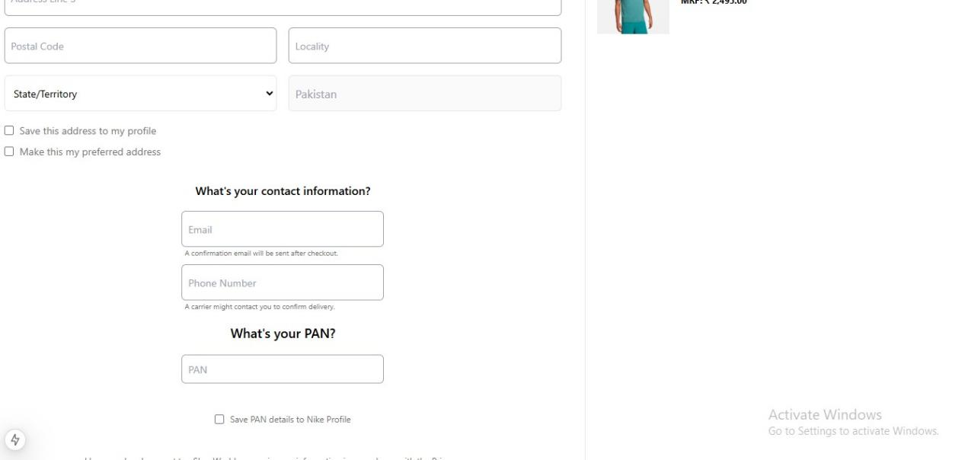

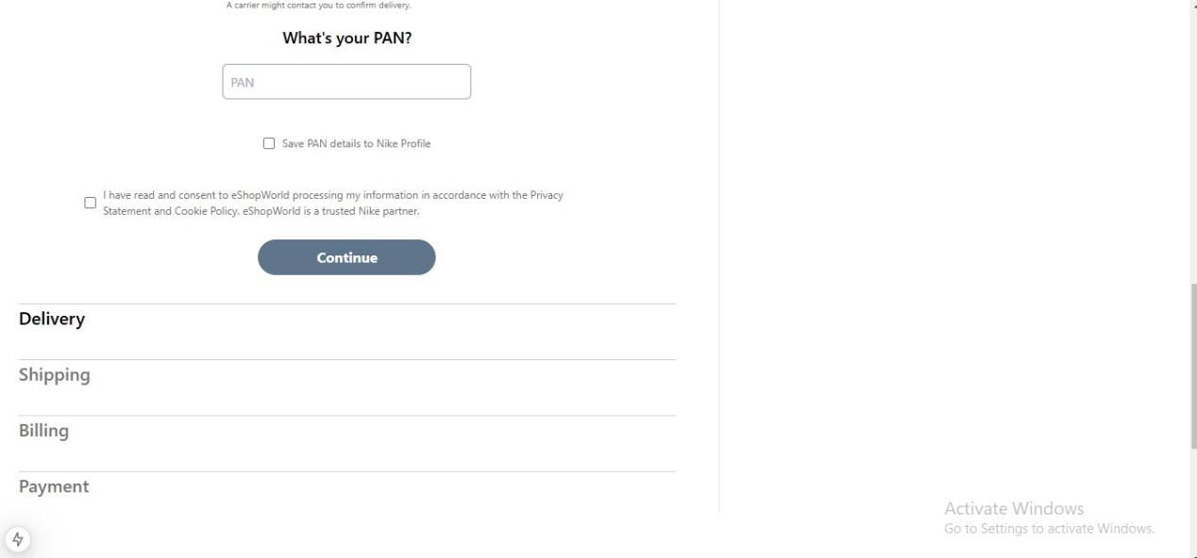

**6.Order Confirmation Components:**

After placing order user get a order confirmation page.

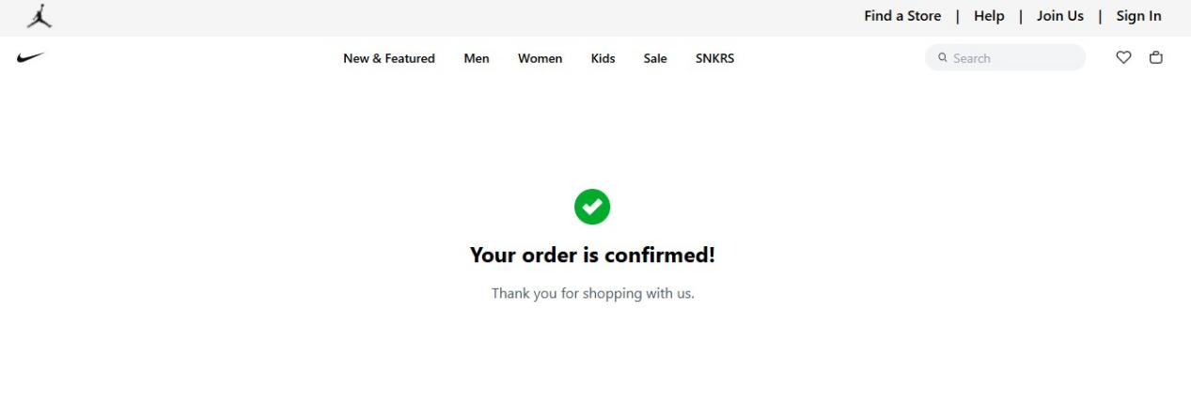

**6.FAQs Component:**

Create a new page of FAQs.where user help out to read FAQs.

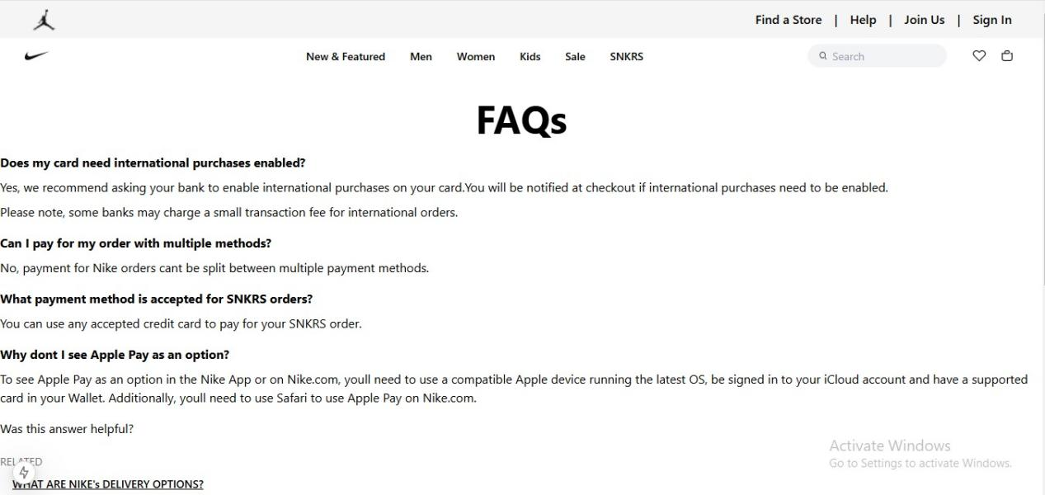

## Conclusion

The dynamic frontend components for Marketplace builder [NIKE] were successfully implemented on Day 4, with functional components which are following below.

1. Product listing page
2. Product detail page components
3. Cart functionality component
4. Checkout functionality component
5. Order confirmation message component
6. FAQs components